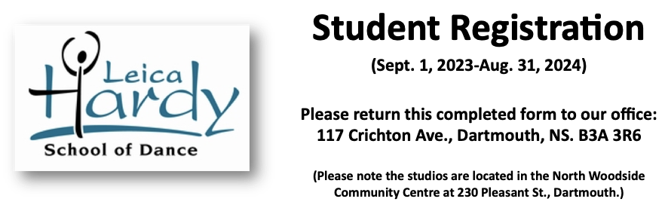

Student Information:

First Name: |  |  | Last Name:
Birth Date: |  |  | School:
Mobile: |  | Home Phone: |  | Work Phone:
Email:
Street:
City: |  |  | Postal Code:

Parent or Guardian #1:

First Name: |  |  | Last Name:
Mobile: |  | Home Phone: |  | Work Phone:
Email:

Parent or Guardian #2:

First Name: |  |  | Last Name:
Mobile: |  | Home Phone: |  | Work Phone:
Email:

Emergency Contact (other than Parent or Guardian):
Name: |  |  | Relationship to Student:
Mobile: |  | Home Phone: |  | Work Phone:
Email:
Medical Information:

MSI#: |  | Dr. Name:
Dr. Phone (Day): |  | Dr. Phone (Eve.):
Allergies/Conditions/Medications:

I, (name of student 19 or older, or parent/guardian), in consideration of myself/my child/my charge (child’s name) being allowed to participate in classes offered by the Leica Hardy School of Dance (LHSD), do hereby release and agree to hold harmless and indemnify LHSD, its Artistic Director, consultants and employees, from any and all claims, actions, damages, costs, expenses, without limitation whatsoever, whether consisting of loss, personal injury, illness, and/or property damage that may occur as a result of participation. I acknowledge that I/my child/my charge (child’s name) am/is in good health and physically fit to participate in any classes offered. I grant my consent to the LHSD to take photographs/video of myself/my child/my charge participating in school activities, and to use such materials for promotional and educational purposes without compensation. I have read and understood this agreement and all policies published on the website and agree to their terms and conditions. I grant permission to the LHSD to use the email addresses on page one of this form for school communication purposes.

________________________________________________ ____________________________
Signature of student 19 or older, or Parent/Guardian Date

Please register me for the following classes:
How did you hear about us?

