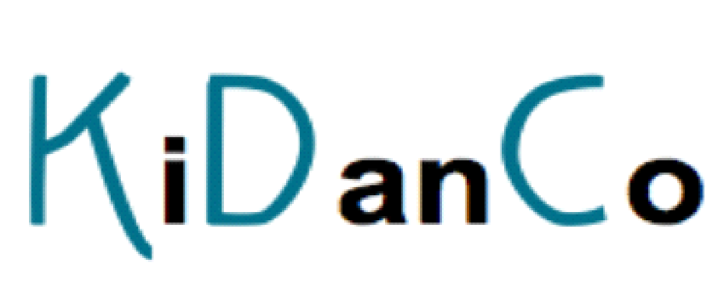
Java Blend Coffee Fundraiser

Customer Name:

Customer Phone:

Customer Email:
To place your coffee order:
- Please fill out the chart below with your order. Orders may also be placed via email to info@leicahardyschoolofdance.com, containing all the information in this order form.
- On the line for the coffee blend of your choice, indicate the number of whole bean or ground bags you want to purchase.
- Calculate the total amount owing on the line for each blend.
- Add up the total owing.
- Email this completed order form, accompanied by an E-transfer payment to info@leicahardyschoolofdance.com by April 30, 2026.

Coffee Blend | Number of Whole Bean Bags | Number of Ground Bags | Total Number of Bags | Total Cost @  $16/bag or  2 for $30
Dark Roast |  |  |  | $
Medium Roast |  |  |  | $
Decaf |  |  |  | $
 |  |  | Total Order: | $

KiDanCo is the Leica Hardy School of Dance’s resident pre-professional company, offering nationally recognized training, choreographic collaborations, and performance opportunities for gifted young dancers. For more information about the company, please visit the website: www.leicahardyschoolofdance.com/kidanco.

Thank you for supporting KiDanCo.

